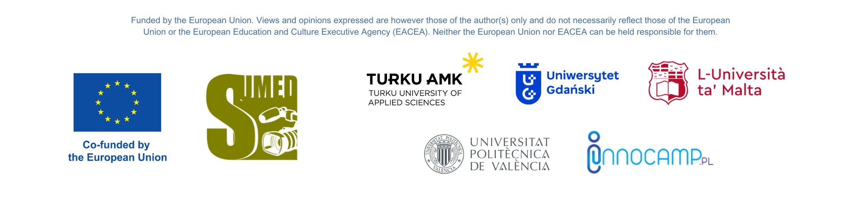

Project: SUMED
Curriculum Design Workshop for educators: 'How to embed green media content in curricula' - summary and conclusions

The workshop entitled Curriculum Design Workshop for educators: 'How to embed green media content in curricula' within the framework of the project: SUMED - Sustainable multidimensional media education content, was held on June 5th 2023 in an online format. The meeting was organized by the project partner: University of Gdansk, and they were led by dr. Beata Czechowska-Derkacz from the Institute of Media, Journalism and Social Communication, the project manager on behalf of UG.

They lasted a total of three and a half hours and were divided into three parts. The introduction - discussion of the SUMED project, presentation of the partners' submitted goals and results to date - was prepared by dr Adam Jagiello Rusilowski, representing the project leader: INNOCAMP PL.

The workshop was very well recieved, and the online formula allowed it to be international. More than twenty people from four countries participated: Malta, Turku, Spain and Poland. These were academic teachers and researchers from the University of Gdansk (Poland), Turku University of Applied Sciences (Finland), Universitat Politecnics De Valencia, (Spain), University of Malta (Malta) as well as other people interested in the topics of the SUMED project.

The workshop was aimed at academics and all those interested in creating intersecting curricula, especially creative syllabus writing with the use of media as a tool for promoting green attitudes and the use of modern educational tools in media education.

The training was conducted by experts from the University of Gdansk and the University of Malta:

Dr Monika Maslowska from the University of Malta: led a workshop entitled: 'Sustainability, Creativity and Pedagogy in Teaching Eco-Screenwriting', in which she presented methods for teaching creative screenwriting for videos using sustainability content. The content of the workshop included:
“Going green” inspires and educates the world of screen production by creating and promoting sustainable working practices. By reducing the environmental impact of filming essentials such as transport, construction, lighting and catering. “Going green” leads screen productions into a greener way of life, but what does it mean for us, the screenwriters and screenwriting teachers? How can we contribute to “going green”?

Dr Ewelina Gutowska-Kozielska from the University of Gdansk during the workshop: 'Media, education & social responsibility' reminded the audience of the need to promote in academia the social responsibility of science and universities based on the fundamental principles of tolerance, equality, openness and social justice and democracy, and presented opportunities to use the media for these purposes. The content of the workshop included:
How media can provide a great platform for education & contribute to CSR. Media content can be used for educational purposes & thus contribute to the development of critical thinking as a part of CSR. Media texts can be used for educational purposes in two ways - one, some of them have been created for that purpose, others - when audiences are equipped with proper tools can be used for education independently of the fact whether that was the reason for their creations in the first place. We must remember about the fact that the profile of the recipient, the way of perceiving the world by young people has changed. Students gain knowledge mainly from the media, so it is important to educate them using messages they know. We must use platforms that are of interest to our students to teach them the content that is of interest to us.

Dr Magdalenia Bulińska from the University of Gdansk presented modern teaching methods and their effectiveness in media and acdemic education during a workshop: 'Creative teaching and modern teaching tools'. The content of the workshop included:
The aim of the workshop is to introduce modern teaching methods and tools aimed at developing among students the competences defined as future competences (including creativity and innovation, teamwork skills, independence and self-education, critical thinking, problem-solving skills, sensitivity to culture and diversity, sustainable development). During the workshop, we will share experiences in the field of modern teaching methods and their potential use in the context of media education, in order to increase the effectiveness of the teaching process and motivate students to actively participate in the education process.

The workshop ended with a discussion, based on which the following conclusions were drawn:

1. Media sustainability is still understood too narrowly: as the promotion of environmental content and attitudes in the media. Overlooked or underrepresented are the following contents:
- social responsibility of the media (e.g., the topics covered, responsibility for the word),
- sustainable media education: teaching students in an educational environment that is safe for them
- work-life balance in media and perimedia professions, and individual well-being,
- promoting and teaching the core values of a democratic society: tolerance, openness, equality,
- eliminating the language of fear and hatred from the area of sustainable development.
These are areas to be strengthened during the SUMED project.

2. Media education, especially on new phenomena such as infodemia, denialism, post-truth, fake news - requires new tools in academic teaching. Proposing creative teaching with modern tools should be one of the important elements of the SUMED project

3. In the current state of threat of climate catastrophe and environmental degradation, the media are particularly predisposed to promote environmental content and attitudes. This should be one of the basic points in their social mission. The SUMED project should propose creative ways to disseminate such content.

4. The idea of sustainable development should guide the activities of the entire academic community. The SUMED project can be one of the tools for disseminating this idea.

Professional experience of female experts leading the workshop:
Monika Maslowska is a screenwriter, script development expert, script supervisor, mentor and educator based in Malta. She teaches screenwriting and screen production at the University of Malta and the Institute for Education (Malta). She also collaborates with the Ministry for Sport, Youth, Research and Innovation training media literacy teachers and young adolescents in cinematic writing.

Ewelina Gutowska-Kozielska is an Americanist, interested in culture and media, a researcher of constitutive rhetoric and feminism. She worked as the director of the Institute of English and American Studies of the University of Gdańsk, and then Vice-dean for student affairs at the Faculty of Philology. Educator, deputy director of the alternative school Żyrafia Osada in Gdańsk, a school that does it differently. A nature and books lover, mother, wife and friend.

Magdalena Bulińska is an English and Iberian Studies graduate of Interfaculty Philology at the University of Warsaw. Have been affiliated with the University of Gdańsk since 2013 and have been working as an assistant professor in the Department of Iberian Studies since 2019. Defended doctoral thesis in literary studies, researching proper names in American borderland women's literature. Research interests include: women's borderland literature and literary translation and quality education. She is a tutor and cooperate with the University of Gdansk Center for the Development of Teaching and Tutoring by conducting courses and training for university staff.

About the project SUMED:

This is a teaching project under the Erasmus Plus Program. Priority/Measure: Cooperation partnerships in higher education (KA220-HED), as part of an international partnership. The project leader is INNOCAMP PL Spółka z o.o. (Poland). Project partners: University of Gdansk (Poland), Turku University of Applied Sciences (Finland), Universitat Politecnics De Valencia (Spain), University of Malta (Malta).

The project manager on behalf of the University of Gdansk is Dr. Beata Czechowska-Derkacz (Institute of Media, Journalism and Social Communication UG).

The project is being implemented from November 1, 2022, scheduled completion: October 31, 2025.

Dynamic changes in the media, both in terms of technology and content resources, require new ways of media education and methods of media production. Continuous changes in media trends affect the way content is created and reached. The main goal of the project is to promote sustainability, technology and digital solutions in the higher education sector and the labor market by organizing courses and workshops for teachers and support sustainable development.

Beata Czechowska-Derkacz, project manager on behalf of the University of Gdansk, Institute of Media, Journalism and Social Communication UG

